Name: Datu, Jexter Reigner P

Year | Section: BSIT-3

Date: May 15, 2024 – **Deadline will be today at 6:25 PM only.**

This must be the name of your word document – LASTNAME_INITIAL(APPDEV-MID) **TUNGUL_RD(APPDEV-MID)**

**(MIDTERM EXAM) APPLICATION DEVELOPMENT**

1. Create a Copy and Paste website content that can cater the audience need (i.e., copying the machine/devices text or files):

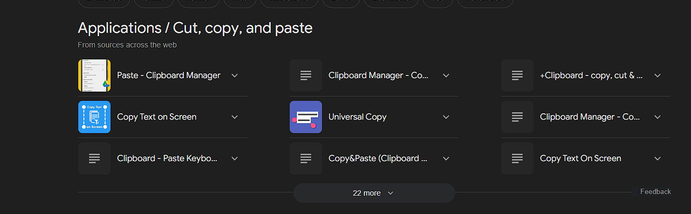

1. Upload your file via GitHub and named it as: username.github.io/appdev-midterm

https://jexterdry08.github.io/Datu_JR-APPDEV-MIDTERM/

1. Create your own sentence/wordings and replace all the Lorem ipsum text into your generated sentences (Note: images and icons are fixed). Add a metadata inside the head section. Please make sure that your design is 1:1, unique, and up to date:

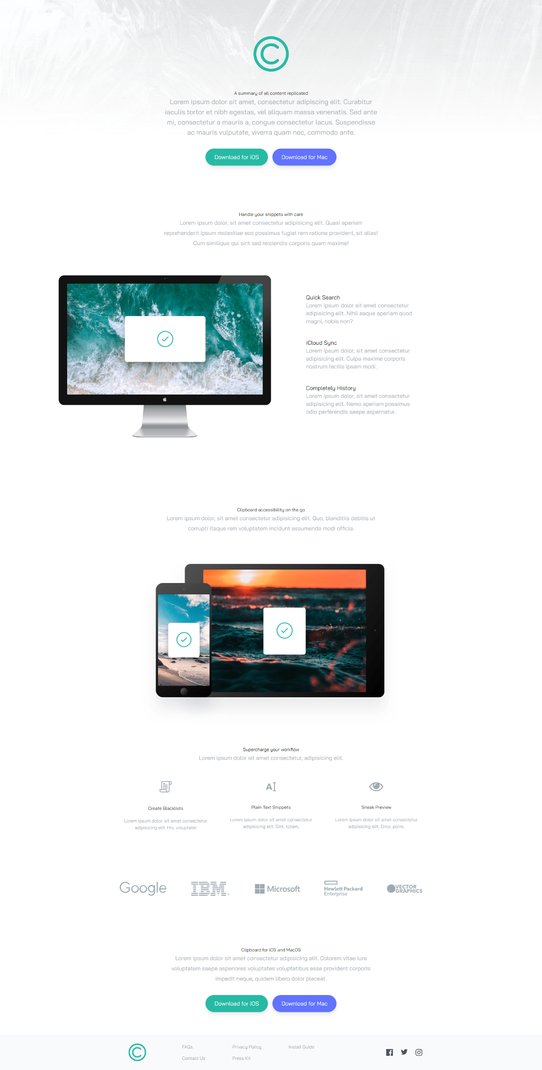

1. Make the site’s speed up to 98% on all aspects using Google PageSpeed Insights. (Note: Web layout only)

1. Network speed must be faster than the original speed. (Note: speed must be less than 2.5 seconds)

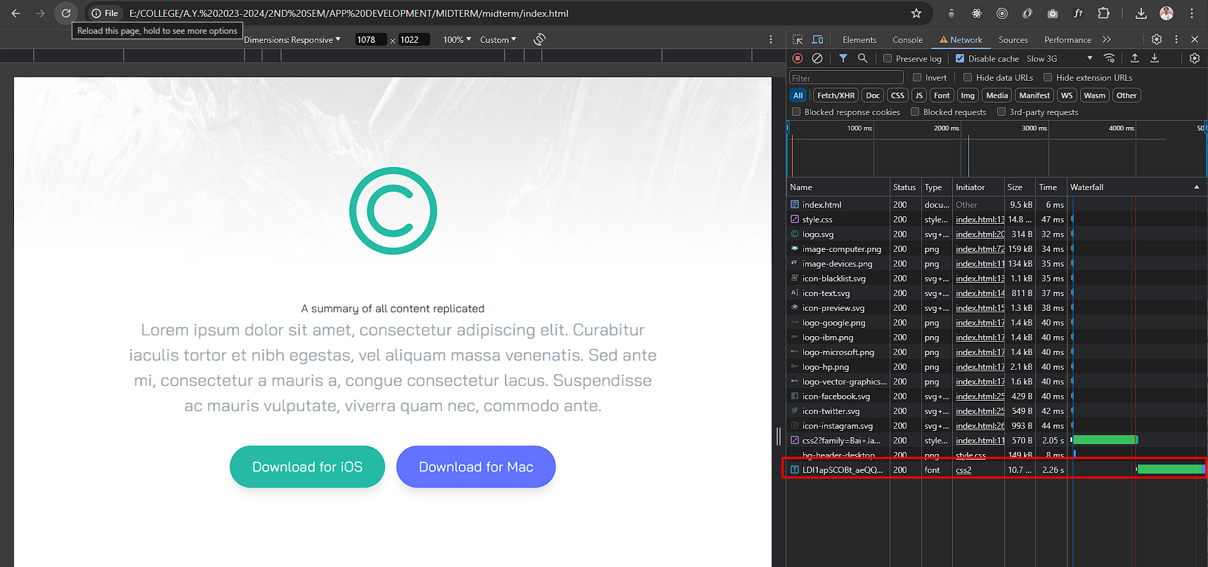

Save your screenshots here:

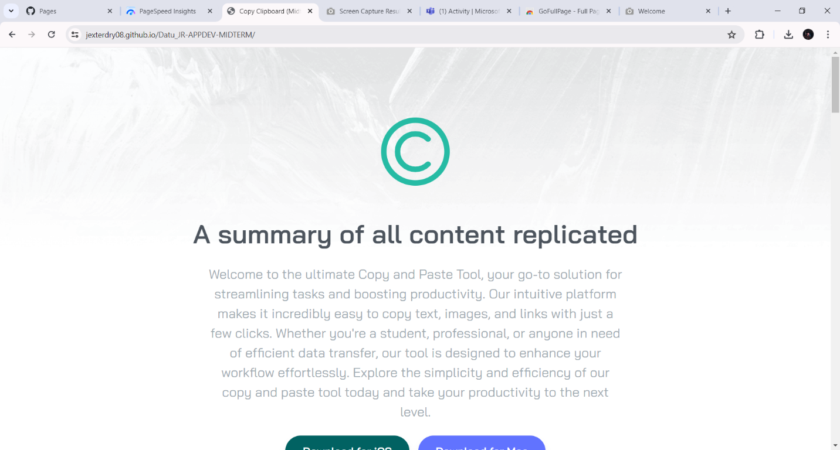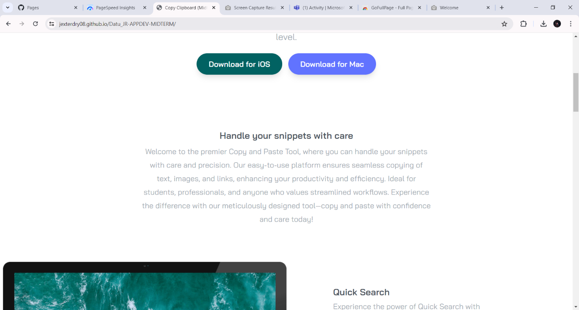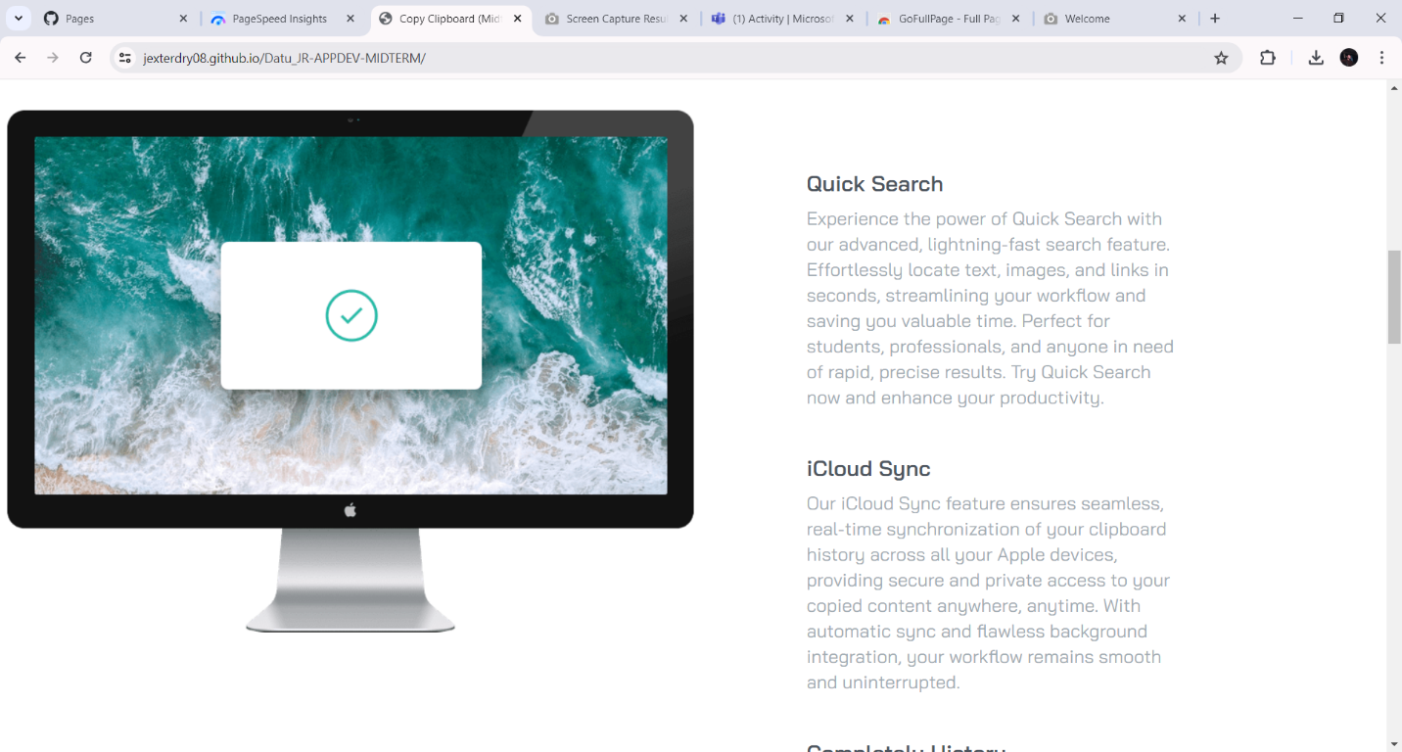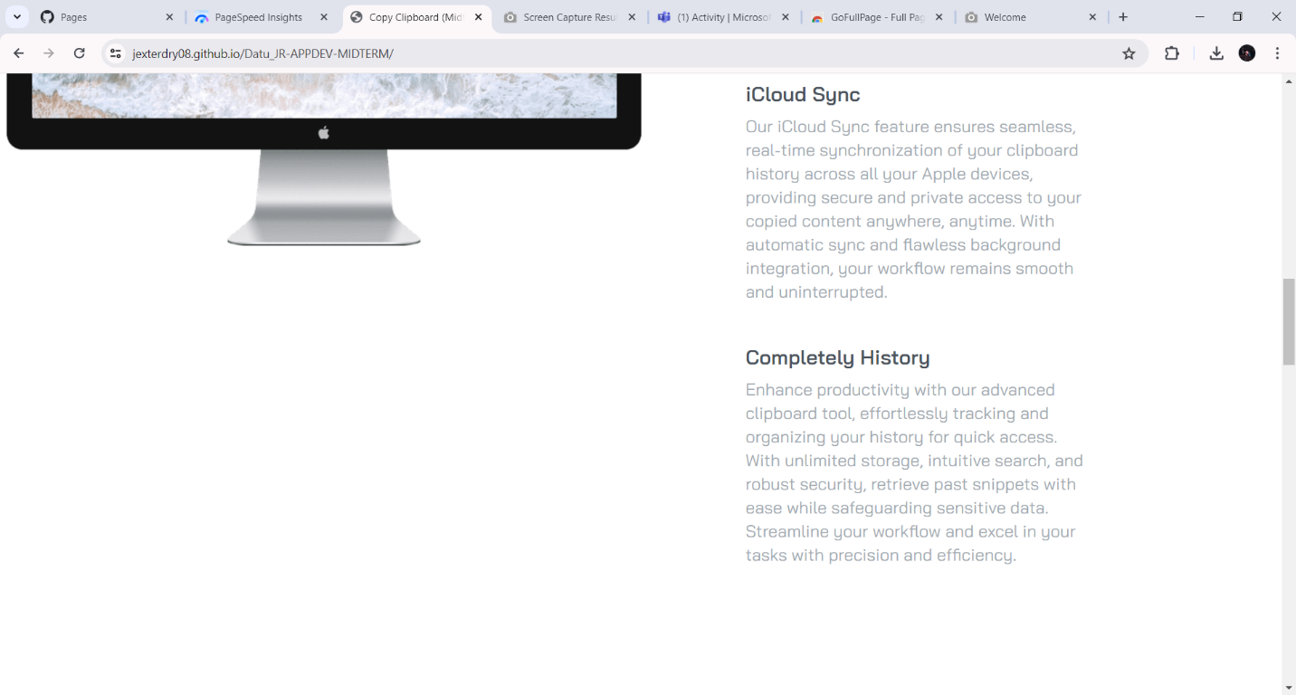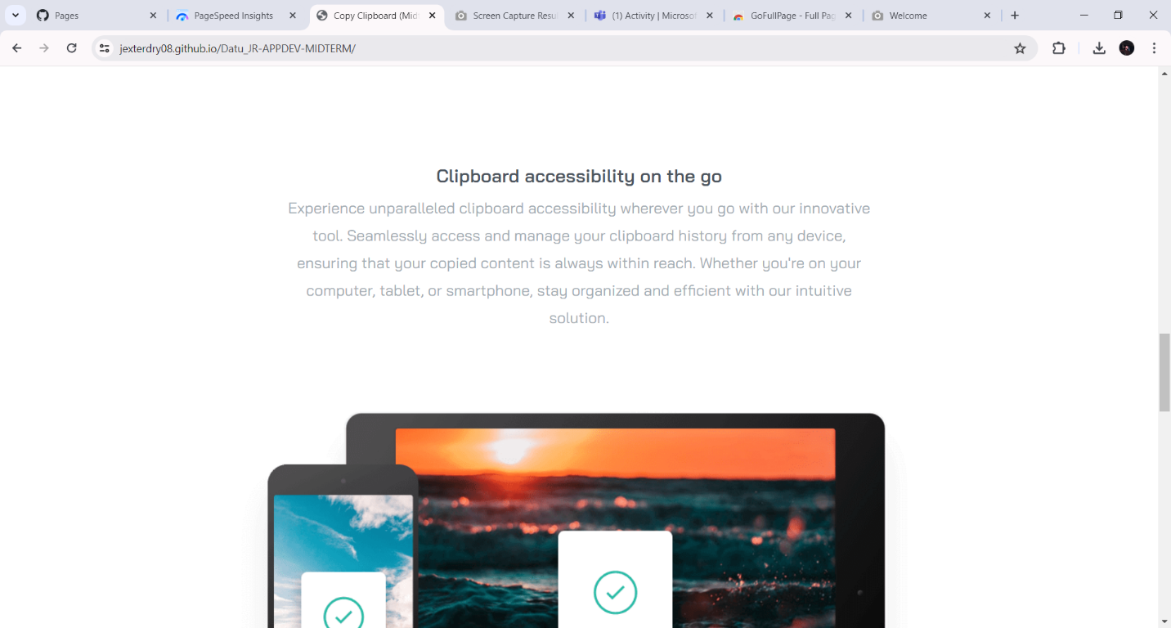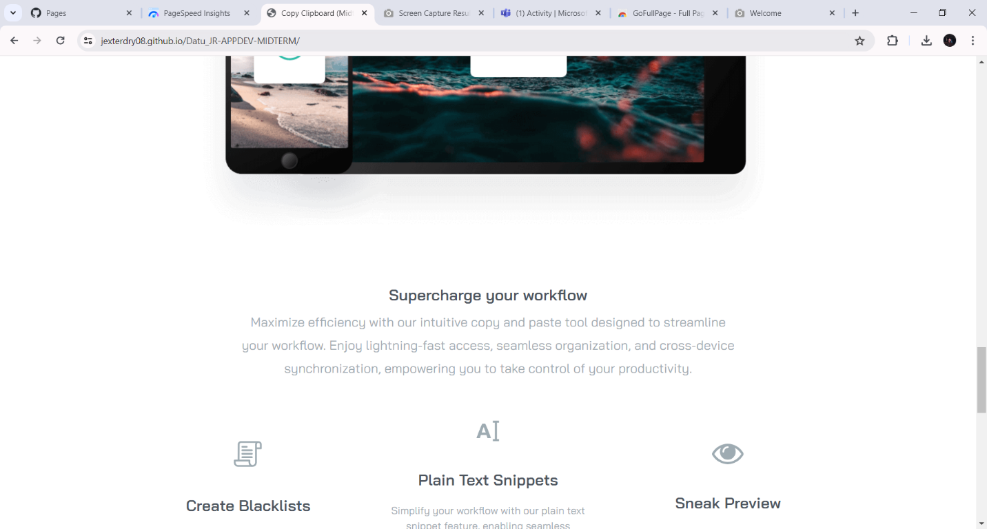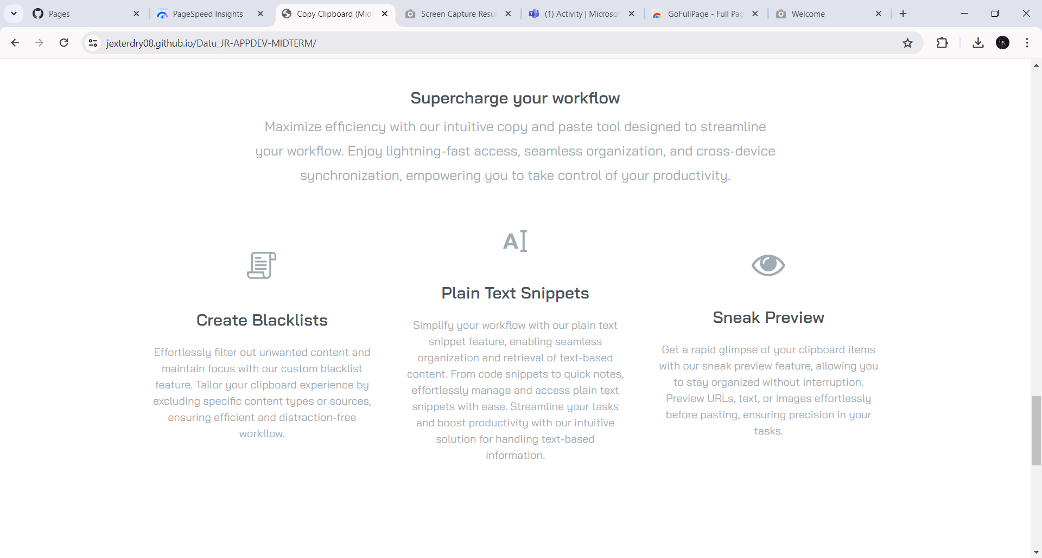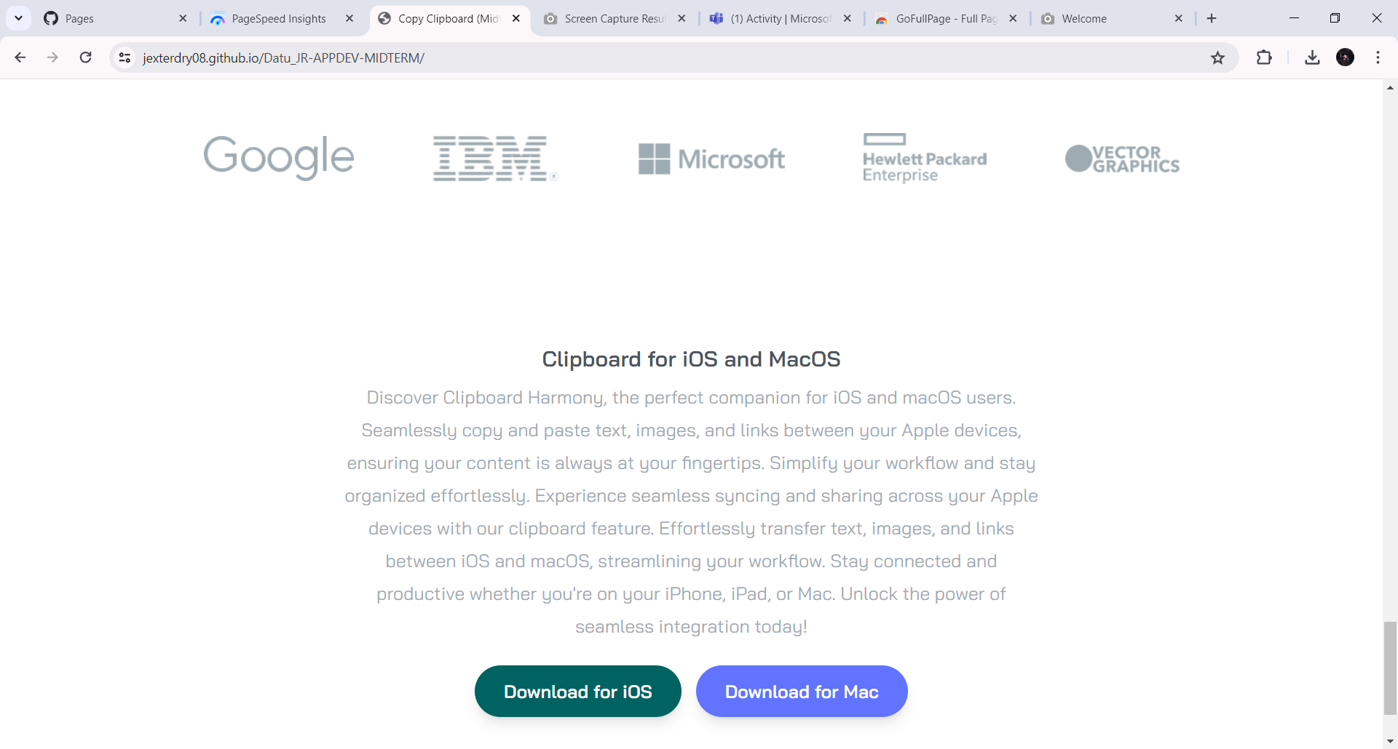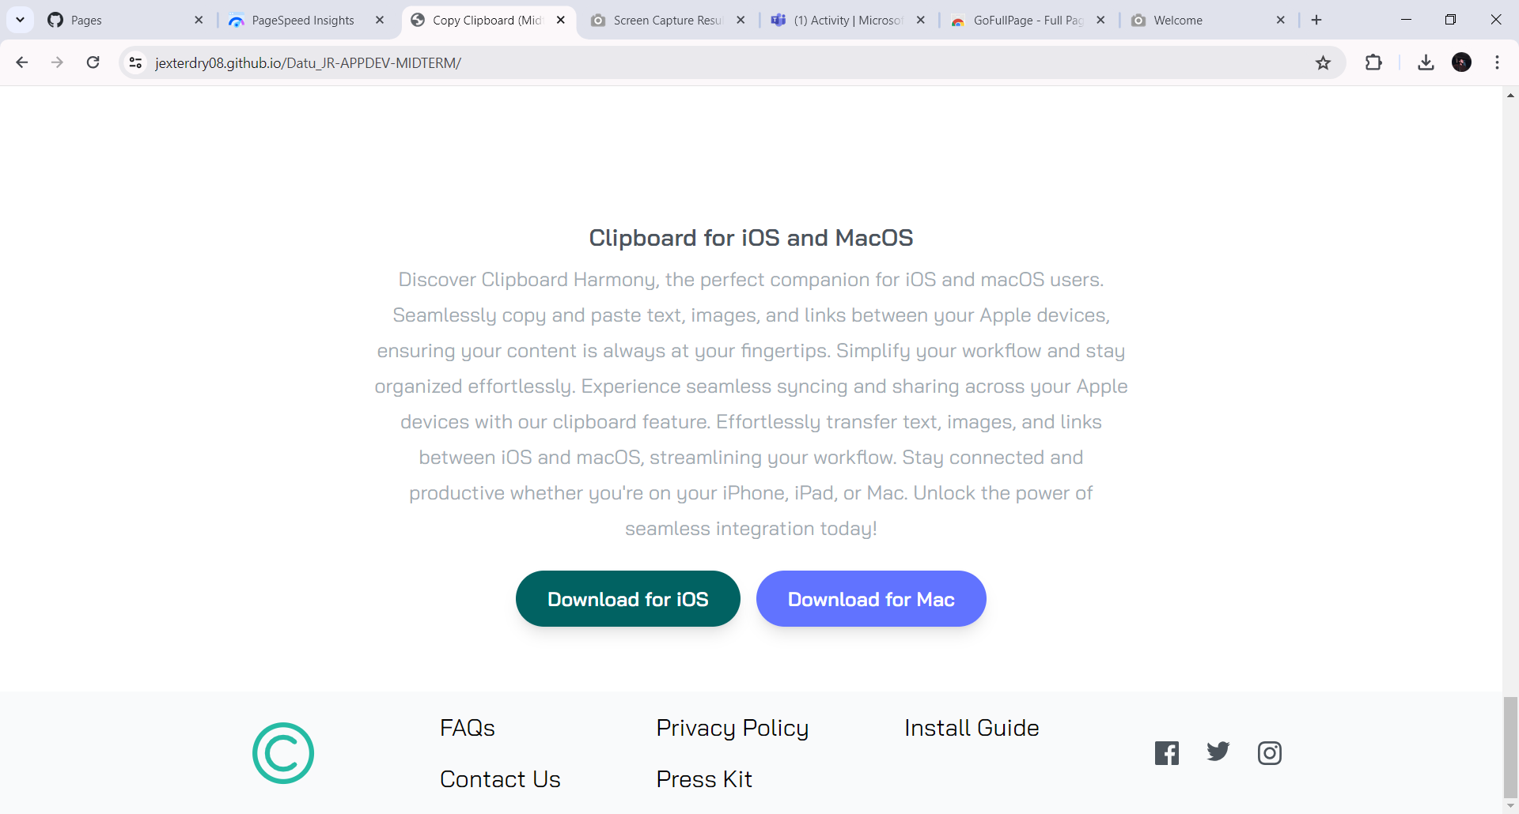

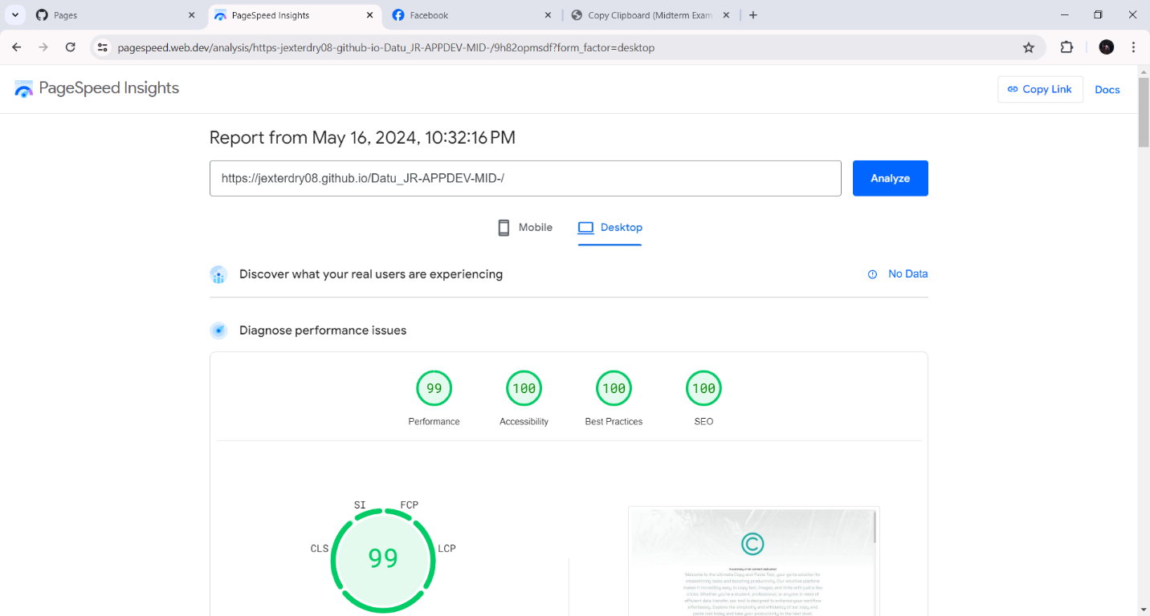

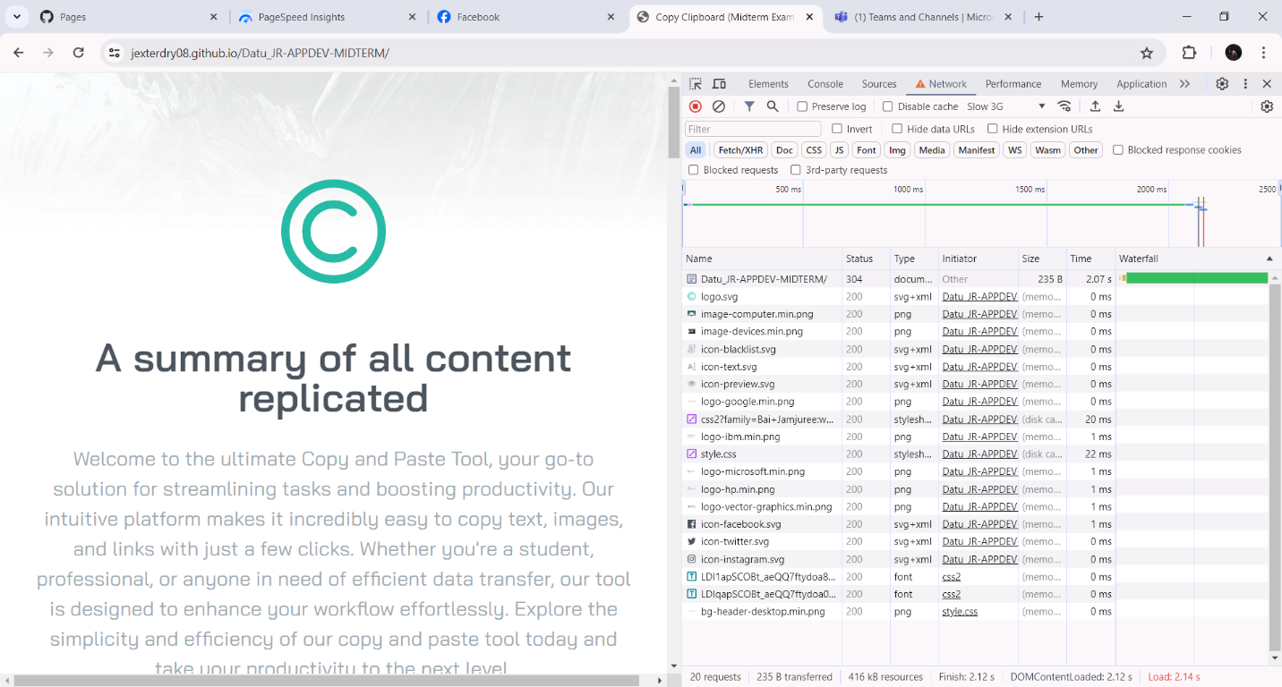

Save your code here:

#HTML MINIFIED

<!DOCTYPE html>

<html lang="en">

<head>

<meta charset="UTF-8">

<meta name="viewport" content="width=device-width,initial-scale=1">

<meta title="Copy Clipboard (Midterm Exam)">

<meta name="description"

content="Discover the ultimate online copy and paste tool designed to simplify your tasks. Our user-friendly interface allows you to quickly copy text, images, and links with just a few clicks. Perfect for students, professionals, and anyone looking to boost productivity. Experience seamless data transfer and enhanced efficiency today. Try our free copy and paste tool now!">

<meta name="keywords" content="copy, paste, clipboard">

<meta name="author" content="Rsoseph Tungul">

<link rel="preconnect" href="https://fonts.googleapis.com">

<link rel="preconnect" href="https://fonts.gstatic.com" crossorigin>

<link href="https://fonts.googleapis.com/css2?family=Bai+Jamjuree:wght@400;600&display=swap" rel="stylesheet">

<link rel="stylesheet" href="css/style.css">

<title>Copy Clipboard (Midterm Exam)</title>

</head>

<body>

<section id="hero">

<div class="pt-16 mb-40 section-container"><img src="images/logo.svg" alt="this is logo" class="mx-auto my-16">

<h3>A summary of all content replicated</h3>

<p class="mb-10 text-2xl section-content">Welcome to the ultimate Copy and Paste Tool, your go-to solution for

streamlining tasks and boosting productivity. Our intuitive platform makes it incredibly easy to copy text,

images, and links with just a few clicks. Whether you're a student, professional, or anyone in need of efficient

data transfer, our tool is designed to enhance your workflow effortlessly. Explore the simplicity and efficiency

of our copy and paste tool today and take your productivity to the next level.</p>

<div class="button-container"><button><a href="button1"

class="p-4 px-8 duration-200 rounded-full shadow-lg bg-strongCyan hover:opacity-80" style="font-weight: 800; background-color: rgb(1, 98, 98);">Download for

iOS</a></button><button><a href="button1"

class="p-4 px-8 duration-200 rounded-full shadow-lg bg-lightBlue hover:opacity-80" style="font-weight: 800;">Download for

Mac</a></button></div>

</div>

</section>

<section id="snippets">

<div class="my-20 section-container">

<h5>Handle your snippets with care</h5>

<p class="mb-24 text-xl section-content">Welcome to the premier Copy and Paste Tool, where you can handle your

snippets with care and precision. Our easy-to-use platform ensures seamless copying of text, images, and links,

enhancing your productivity and efficiency. Ideal for students, professionals, and anyone who values streamlined

workflows. Experience the difference with our meticulously designed tool—copy and paste with confidence and care

today!</p>

</div>

</section>

<section id="features">

<div class="my-20 section-container">

<div class="relative flex flex-col md:flex-row md:space-x-32">

<div class="md:w-1/2"><img src="images/image-computer.min.png" alt="this is computer" class="md:absolute top-0 right-[50%]">

</div>

<div class="flex flex-col mt-16 mb-24 space-y-12 text-xl md:w-1/2 md:mb-60 md:text-left md:pl-16">

<div>

<h5>Quick Search</h5>

<p class="max-w-md text-grayishBlue">Experience the power of Quick Search with our advanced, lightning-fast

search feature. Effortlessly locate text, images, and links in seconds, streamlining your workflow and

saving you valuable time. Perfect for students, professionals, and anyone in need of rapid, precise

results. Try Quick Search now and enhance your productivity.</p>

</div>

<div>

<h5>iCloud Sync</h5>

<p class="max-w-md text-grayishBlue">Our iCloud Sync feature ensures seamless, real-time synchronization of

your clipboard history across all your Apple devices, providing secure and private access to your copied

content anywhere, anytime. With automatic sync and flawless background integration, your workflow remains

smooth and uninterrupted.</p>

</div>

<div>

<h5>Completely History</h5>

<p class="max-w-md text-grayishBlue">Enhance productivity with our advanced clipboard tool, effortlessly

tracking and organizing your history for quick access. With unlimited storage, intuitive search, and

robust security, retrieve past snippets with ease while safeguarding sensitive data. Streamline your

workflow and excel in your tasks with precision and efficiency.</p>

</div>

</div>

</div>

</div>

</section>

<section id="access">

<div class="my-20 section-container">

<h5>Clipboard accessibility on the go</h5>

<p class="mb-24 text-xl section-content">Experience unparalleled clipboard accessibility wherever you go with our

innovative tool. Seamlessly access and manage your clipboard history from any device, ensuring that your copied

content is always within reach. Whether you're on your computer, tablet, or smartphone, stay organized and

efficient with our intuitive solution.</p><img src="images/image-devices.min.png" alt="this is devices" class="mx-auto">

</div>

</section>

<section id="supercharge">

<div class="my-20 section-container">

<h5>Supercharge your workflow</h5>

<p class="mb-16 text-xl section-content">Maximize efficiency with our intuitive copy and paste tool designed to

streamline your workflow. Enjoy lightning-fast access, seamless organization, and cross-device synchronization,

empowering you to take control of your productivity.</p>

<div class="flex flex-col items-center justify-between space-y-16 md:flex-row md:space-y-0 md:space-x-12">

<div class="flex flex-col items-center space-y-5"><img src="images/icon-blacklist.svg" alt="this is blacklists" class="mb-6">

<h5>Create Blacklists</h5>

<p class="max-w-md text-grayishBlue">Effortlessly filter out unwanted content and maintain focus with our

custom blacklist feature. Tailor your clipboard experience by excluding specific content types or sources,

ensuring efficient and distraction-free workflow.</p>

</div>

<div class="flex flex-col items-center space-y-5"><img src="images/icon-text.svg" alt="icon for text" class="mb-6">

<h5>Plain Text Snippets</h5>

<p class="max-w-md text-grayishBlue">Simplify your workflow with our plain text snippet feature, enabling

seamless organization and retrieval of text-based content. From code snippets to quick notes, effortlessly

manage and access plain text snippets with ease. Streamline your tasks and boost productivity with our

intuitive solution for handling text-based information.</p>

</div>

<div class="flex flex-col items-center space-y-5"><img src="images/icon-preview.svg" alt="this is preview" class="mb-6">

<h5>Sneak Preview</h5>

<p class="max-w-md text-grayishBlue">Get a rapid glimpse of your clipboard items with our sneak preview

feature, allowing you to stay organized without interruption. Preview URLs, text, or images effortlessly

before pasting, ensuring precision in your tasks.</p>

</div>

</div>

</div>

</section>

<section id="references">

<div

class="flex flex-col items-center justify-between max-w-6xl px-10 mx-auto space-y-16 my-44 md:flex-row md:space-y-0">

<img src="images/logo-google.min.png" alt="logo for google"> <img src="images/logo-ibm.min.png" alt="logo for ibm"> <img

src="images/logo-microsoft.min.png" alt="logo for microsoft"> <img src="images/logo-hp.min.png" alt="logo for hp"> <img

src="images/logo-vector-graphics.min.png" alt="logo for vector"></div>

</section>

<section id="bottom">

<div class="my-20 section-container">

<h5>Clipboard for iOS and MacOS</h5>

<p class="mb-10 text-xl section-content">Discover Clipboard Harmony, the perfect companion for iOS and macOS

users. Seamlessly copy and paste text, images, and links between your Apple devices, ensuring your content is

always at your fingertips. Simplify your workflow and stay organized effortlessly. Experience seamless syncing

and sharing across your Apple devices with our clipboard feature. Effortlessly transfer text, images, and links

between iOS and macOS, streamlining your workflow. Stay connected and productive whether you're on your iPhone,

iPad, or Mac. Unlock the power of seamless integration today!</p>

<div class="button-container"><button><a href="button2"

class="p-4 px-8 duration-200 rounded-full shadow-lg bg-strongCyan hover:opacity-80" style="font-weight: 800; background-color: rgb(1, 98, 98);">Download for

iOS</a></button><button><a href="button2"

class="p-4 px-8 duration-200 rounded-full shadow-lg bg-lightBlue hover:opacity-80" style="font-weight: 800">Download for

Mac</a></button></div>

</div>

</section>

<footer class="bg-gray-50">

<div class="section-container">

<div class="flex flex-col items-center justify-between md:flex-row"><img src="images/logo.svg" alt="this is the logo"

class="scale-50">

<div

class="flex flex-col items-center justify-between flex-1 mb-10 space-y-6 md:flex-row md:mb-0 md:space-y-0 text-grayishBlue">

<div class="flex flex-col space-y-4 md:flex-row md:ml-24 md:space-x-24 md:space-y-0">

<div class="flex flex-col space-y-4 text-center md:text-left">

<div><a href="#1" class="hover:text-strongCyan" style="color: black; font-size: 24px">FAQs</a></div>

<div><a href="#2" class="hover:text-strongCyan" style="color: black; font-size: 24px">Contact Us</a></div>

</div>

<div class="flex flex-col space-y-4 text-center md:text-left">

<div><a href="#3" class="hover:text-strongCyan" style="color: black; font-size: 24px">Privacy Policy</a></div>

<div><a href="#4" class="hover:text-strongCyan" style="color: black; font-size: 24px">Press Kit</a></div>

</div>

<div class="flex flex-col space-y-4 text-center md:text-left">

<div><a href="#5" class="hover:text-strongCyan" style="color: black; font-size: 24px">Install Guide</a></div>

</div>

</div>

<div class="flex justify-between w-32 py-1"><a href="https://www.facebook.com/"><img src="images/icon-facebook.svg" alt="this is our facebook social platform"

class="duration-200 ficon"></a><a href="https://www.twitter.com/"><img src="images/icon-twitter.svg" alt="this is our twitter social platform"

class="duration-200 ficon"></a><a href="https://www.instagram.com/"><img src="images/icon-instagram.svg" alt="this is our instagram social platform"

class="duration-200 ficon"></a></div>

</div>

</div>

</div>

</footer>

</body>

</html>

**#CSS MINIFIED**

a,

hr {

color: inherit

}

progress,

sub,

sup {

vertical-align: baseline

}

blockquote,

body,

dd,

dl,

fieldset,

figure,

h1,

h2,

h3,

h4,

h5,

h6,

hr,

menu,

ol,

p,

pre,

ul {

margin: 0

}

fieldset,

legend,

menu,

ol,

ul {

padding: 0

}

.relative,

sub,

sup {

position: relative

}

.mx-auto,

.section-container,

.section-content {

margin-left: auto;

margin-right: auto

}

.section-content,

.text-center {

text-align: center

}

.section-content,

.text-grayishBlue {

color: hsl(201 11% 66% / var(--tw-text-opacity))

}

*,

::after,

::before {

box-sizing: border-box;

border: 0 solid #e5e7eb;

--tw-translate-x: 0;

--tw-translate-y: 0;

--tw-rotate: 0;

--tw-skew-x: 0;

--tw-skew-y: 0;

--tw-scale-x: 1;

--tw-scale-y: 1;

--tw-pan-x: ;

--tw-pan-y: ;

--tw-pinch-zoom: ;

--tw-scroll-snap-strictness: proximity;

--tw-ordinal: ;

--tw-slashed-zero: ;

--tw-numeric-figure: ;

--tw-numeric-spacing: ;

--tw-numeric-fraction: ;

--tw-ring-inset: ;

--tw-ring-offset-width: 0px;

--tw-ring-offset-color: #fff;

--tw-ring-color: rgb(59 130 246 / 0.5);

--tw-ring-offset-shadow: 0 0 #0000;

--tw-ring-shadow: 0 0 #0000;

--tw-shadow: 0 0 #0000;

--tw-shadow-colored: 0 0 #0000;

--tw-blur: ;

--tw-brightness: ;

--tw-contrast: ;

--tw-grayscale: ;

--tw-hue-rotate: ;

--tw-invert: ;

--tw-saturate: ;

--tw-sepia: ;

--tw-drop-shadow: ;

--tw-backdrop-blur: ;

--tw-backdrop-brightness: ;

--tw-backdrop-contrast: ;

--tw-backdrop-grayscale: ;

--tw-backdrop-hue-rotate: ;

--tw-backdrop-invert: ;

--tw-backdrop-opacity: ;

--tw-backdrop-saturate: ;

--tw-backdrop-sepia:

}

::after,

::before {

--tw-content: ''

}

html {

line-height: 1.5;

-webkit-text-size-adjust: 100%;

-moz-tab-size: 4;

-o-tab-size: 4;

tab-size: 4;

font-family: Bai Jamjuree, sans-serif

}

body {

line-height: inherit;

background-image: url('../images/bg-header-desktop.min.png');

background-repeat: no-repeat;

background-size: contain

}

hr {

height: 0;

border-top-width: 1px

}

abbr:where([title]) {

-webkit-text-decoration: underline dotted;

text-decoration: underline dotted

}

h1,

h2,

h3,

h4,

h5,

h6 {

font-size: inherit;

font-weight: inherit

}

a {

text-decoration: inherit

}

b,

strong {

font-weight: bolder

}

h3,

h5 {

font-weight: 700;

color: hsl(210 10% 33% / var(--tw-text-opacity));

--tw-text-opacity: 1

}

code,

kbd,

pre,

samp {

font-family: ui-monospace, SFMono-Regular, Menlo, Monaco, Consolas, "Liberation Mono", "Courier New", monospace;

font-size: 1em

}

small {

font-size: 80%

}

sub,

sup {

font-size: 75%;

line-height: 0

}

sub {

bottom: -.25em

}

sup {

top: -.5em

}

table {

text-indent: 0;

border-color: inherit;

border-collapse: collapse

}

button,

input,

optgroup,

select,

textarea {

font-family: inherit;

font-size: 100%;

line-height: inherit;

color: inherit;

margin: 0;

padding: 0

}

button,

select {

text-transform: none

}

[type=button],

[type=reset],

[type=submit],

button {

-webkit-appearance: button;

background-color: transparent;

background-image: none

}

:-moz-focusring {

outline: auto

}

:-moz-ui-invalid {

box-shadow: none

}

::-webkit-inner-spin-button,

::-webkit-outer-spin-button {

height: auto

}

[type=search] {

-webkit-appearance: textfield;

outline-offset: -2px

}

::-webkit-search-decoration {

-webkit-appearance: none

}

::-webkit-file-upload-button {

-webkit-appearance: button;

font: inherit

}

summary {

display: list-item

}

menu,

ol,

ul {

list-style: none

}

textarea {

resize: vertical

}

input::-moz-placeholder,

textarea::-moz-placeholder {

opacity: 1;

color: #9ca3af

}

input:-ms-input-placeholder,

textarea:-ms-input-placeholder {

opacity: 1;

color: #9ca3af

}

input::placeholder,

textarea::placeholder {

opacity: 1;

color: #9ca3af

}

[role=button],

button {

cursor: pointer

}

:disabled {

cursor: default

}

audio,

canvas,

embed,

iframe,

img,

object,

svg,

video {

display: block;

vertical-align: middle

}

img,

video {

max-width: 100%;

height: auto

}

[hidden] {

display: none

}

h3 {

margin-bottom: 2rem;

font-size: 2.25rem;

line-height: 2.5rem

}

.text-2xl,

h5 {

font-size: 1.5rem;

line-height: 2rem

}

h5 {

margin-bottom: .5rem

}

.top-0 {

top: 0

}

.right-\[50\%\] {

right: 50%

}

.my-16 {

margin-top: 4rem;

margin-bottom: 4rem

}

.my-20 {

margin-top: 5rem;

margin-bottom: 5rem

}

.my-44 {

margin-top: 11rem;

margin-bottom: 11rem

}

.mb-40 {

margin-bottom: 10rem

}

.mb-10 {

margin-bottom: 2.5rem

}

.mb-24 {

margin-bottom: 6rem

}

.mt-16 {

margin-top: 4rem

}

.mb-16 {

margin-bottom: 4rem

}

.mb-6 {

margin-bottom: 1.5rem

}

.flex {

display: flex

}

.w-32 {

width: 8rem

}

.max-w-md {

max-width: 28rem

}

.max-w-6xl {

max-width: 72rem

}

.flex-1 {

flex: 1 1 0%

}

.scale-50 {

--tw-scale-x: .5;

--tw-scale-y: .5;

transform: translate(var(--tw-translate-x), var(--tw-translate-y)) rotate(var(--tw-rotate)) skewX(var(--tw-skew-x)) skewY(var(--tw-skew-y)) scaleX(var(--tw-scale-x)) scaleY(var(--tw-scale-y))

}

.flex-col {

flex-direction: column

}

.items-center {

align-items: center

}

.justify-between {

justify-content: space-between

}

.space-y-12>:not([hidden])~:not([hidden]) {

--tw-space-y-reverse: 0;

margin-top: calc(3rem * calc(1 - var(--tw-space-y-reverse)));

margin-bottom: calc(3rem * var(--tw-space-y-reverse))

}

.space-y-16>:not([hidden])~:not([hidden]) {

--tw-space-y-reverse: 0;

margin-top: calc(4rem * calc(1 - var(--tw-space-y-reverse)));

margin-bottom: calc(4rem * var(--tw-space-y-reverse))

}

.space-y-5>:not([hidden])~:not([hidden]) {

--tw-space-y-reverse: 0;

margin-top: calc(1.25rem * calc(1 - var(--tw-space-y-reverse)));

margin-bottom: calc(1.25rem * var(--tw-space-y-reverse))

}

.button-container>:not([hidden])~:not([hidden]),

.space-y-6>:not([hidden])~:not([hidden]) {

--tw-space-y-reverse: 0;

margin-top: calc(1.5rem * calc(1 - var(--tw-space-y-reverse)));

margin-bottom: calc(1.5rem * var(--tw-space-y-reverse))

}

.space-y-4>:not([hidden])~:not([hidden]) {

--tw-space-y-reverse: 0;

margin-top: calc(1rem * calc(1 - var(--tw-space-y-reverse)));

margin-bottom: calc(1rem * var(--tw-space-y-reverse))

}

.rounded-full {

border-radius: 9999px

}

.bg-strongCyan {

--tw-bg-opacity: 1;

background-color: hsl(171 66% 44% / var(--tw-bg-opacity))

}

.bg-lightBlue {

--tw-bg-opacity: 1;

background-color: hsl(233 100% 69% / var(--tw-bg-opacity))

}

.bg-gray-50 {

--tw-bg-opacity: 1;

background-color: rgb(249 250 251 / var(--tw-bg-opacity))

}

.p-4 {

padding: 1rem

}

.px-8 {

padding-left: 2rem;

padding-right: 2rem

}

.px-10,

.section-container {

padding-left: 2.5rem;

padding-right: 2.5rem

}

.py-1 {

padding-top: .25rem;

padding-bottom: .25rem

}

.pt-16 {

padding-top: 4rem

}

.text-xl {

font-size: 1.25rem;

line-height: 1.75rem

}

.text-grayishBlue {

--tw-text-opacity: 1

}

.shadow-lg {

--tw-shadow: 0 10px 15px -3px rgb(0 0 0 / 0.1), 0 4px 6px -4px rgb(0 0 0 / 0.1);

--tw-shadow-colored: 0 10px 15px -3px var(--tw-shadow-color), 0 4px 6px -4px var(--tw-shadow-color);

box-shadow: var(--tw-ring-offset-shadow, 0 0 #0000), var(--tw-ring-shadow, 0 0 #0000), var(--tw-shadow)

}

.duration-200 {

transition-duration: .2s

}

.section-container {

max-width: 72rem;

text-align: center

}

.section-content {

max-width: 48rem;

line-height: 2.25rem;

--tw-text-opacity: 1

}

.button-container {

display: flex;

width: 100%;

flex-direction: column;

justify-content: center;

font-size: 1.25rem;

line-height: 1.75rem;

--tw-text-opacity: 1;

color: rgb(255 255 255 / var(--tw-text-opacity))

}

@media (max-width:576px) {

body {

background-image: url('../images/bg-header-mobile.min.png')

}

}

.ficon:hover {

filter: invert(53%) sepia(68%) saturate(434%) hue-rotate(121deg) brightness(101%) contrast(94%)

}

.hover\:text-strongCyan:hover {

--tw-text-opacity: 1;

color: hsl(171 66% 44% / var(--tw-text-opacity))

}

.hover\:opacity-80:hover {

opacity: .8

}

@media (min-width:768px) {

h3 {

font-size: 3rem;

line-height: 1

}

.button-container,

.md\:flex-row {

flex-direction: row

}

.button-container>:not([hidden])~:not([hidden]) {

--tw-space-y-reverse: 0;

margin-top: calc(0px * calc(1 - var(--tw-space-y-reverse)));

margin-bottom: calc(0px * var(--tw-space-y-reverse));

--tw-space-x-reverse: 0;

margin-right: calc(1rem * var(--tw-space-x-reverse));

margin-left: calc(1rem * calc(1 - var(--tw-space-x-reverse)))

}

.md\:absolute {

position: absolute

}

.md\:mb-60 {

margin-bottom: 15rem

}

.md\:mb-0 {

margin-bottom: 0

}

.md\:ml-24 {

margin-left: 6rem

}

.md\:w-1\/2 {

width: 50%

}

.md\:space-x-32>:not([hidden])~:not([hidden]) {

--tw-space-x-reverse: 0;

margin-right: calc(8rem * var(--tw-space-x-reverse));

margin-left: calc(8rem * calc(1 - var(--tw-space-x-reverse)))

}

.md\:space-y-0>:not([hidden])~:not([hidden]) {

--tw-space-y-reverse: 0;

margin-top: calc(0px * calc(1 - var(--tw-space-y-reverse)));

margin-bottom: calc(0px * var(--tw-space-y-reverse))

}

.md\:space-x-12>:not([hidden])~:not([hidden]) {

--tw-space-x-reverse: 0;

margin-right: calc(3rem * var(--tw-space-x-reverse));

margin-left: calc(3rem * calc(1 - var(--tw-space-x-reverse)))

}

.md\:space-x-24>:not([hidden])~:not([hidden]) {

--tw-space-x-reverse: 0;

margin-right: calc(6rem * var(--tw-space-x-reverse));

margin-left: calc(6rem * calc(1 - var(--tw-space-x-reverse)))

}

.md\:pl-16 {

padding-left: 4rem

}

.md\:text-left {

text-align: left

}

}

**#INPUT CSS MINIFIED**

@tailwind base;

@tailwind components;

@tailwind utilities;

@layer base {

h3 {

@apply mb-8 text-4xl font-bold text-darkGrayishBlue md:text-5xl;

}

h5 {

@apply mb-2 text-2xl font-bold text-darkGrayishBlue;

}

}

.section-container {

@apply max-w-6xl mx-auto text-center px-10;

}

.section-content {

@apply max-w-3xl mx-auto leading-9 text-center text-grayishBlue;

}

.button-container {

@apply flex flex-col justify-center w-full space-y-6 text-xl text-white md:flex-row md:space-y-0 md:space-x-4;

}

body {

background-image: url('../images/bg-header-desktop.png');

background-repeat: no-repeat;

background-size: contain;

}

@media (max-width: 576px) {

body {

background-image: url('../images/bg-header-mobile.png');

}

}

.ficon:hover {

filter: invert(53%) sepia(68%) saturate(434%) hue-rotate(121deg)

brightness(101%) contrast(94%);

}

**#WEBSITE**

https://jexterdry08.github.io/Datu_JR-APPDEV-MIDTERM/

*** Warning: Duplicate design for the resume will be investigated and reviewed. ***

Goodluck and keep going! You can do it!

___________________

**Roseph Darl Tungul**

Instructor